**Performing Queries with Google Chronicle**

In this project I am responding alert regarding a potential phishing email received by an employee. I investigate the suspicious domain, *signin.office365x24.com*,using Google Chronicle and also check whether other employees have received emails from it and whether they have visited it.

**Performing a domain search**

First, the domain is looked up using the main search bar of the Chronicle instance. A result pops-up under “DOMAINS” which shows that this domain exists within the data ingested by the SIEM.

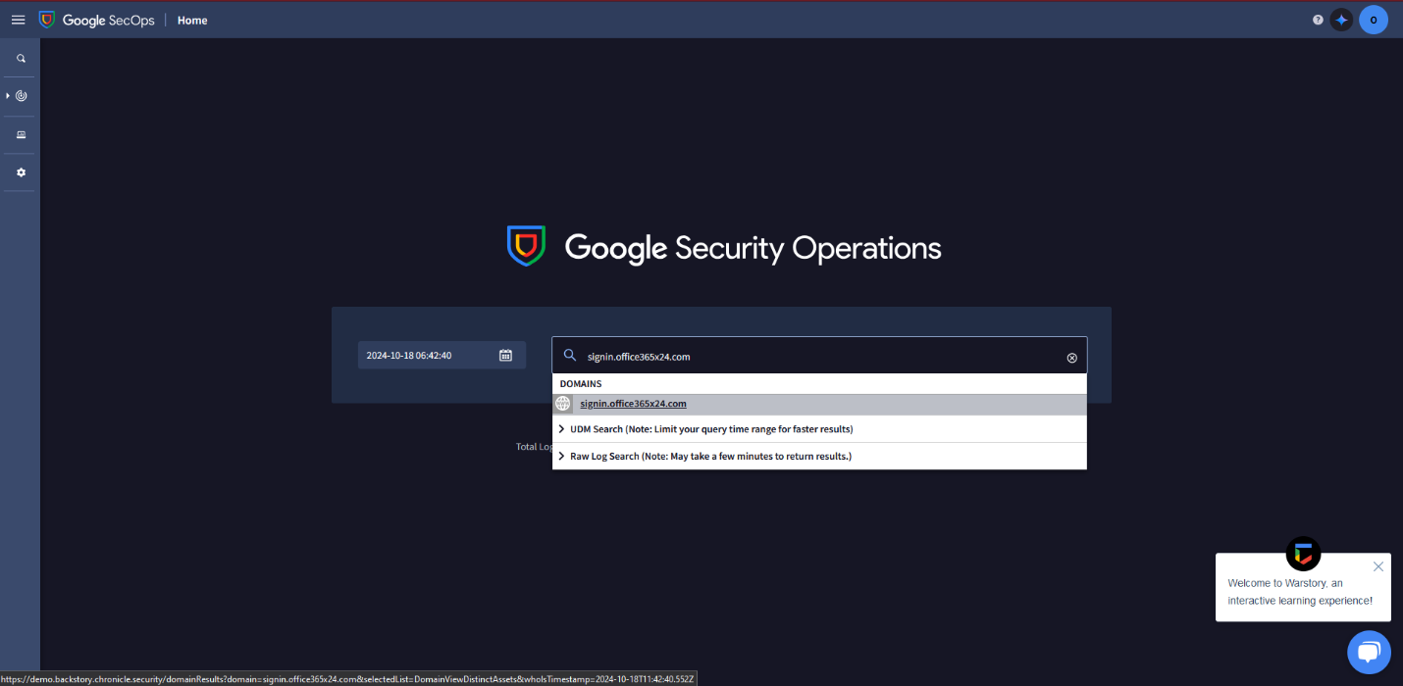

**Investigate Threat Intelligence Data**

Now that there is access to the search results, we need to identify whether the domain is malicious. In Google Chonicle, threat intelligence data can be viewed by clicking on the **VT CONTEXT** to analyse VirusTotal information about the domain.

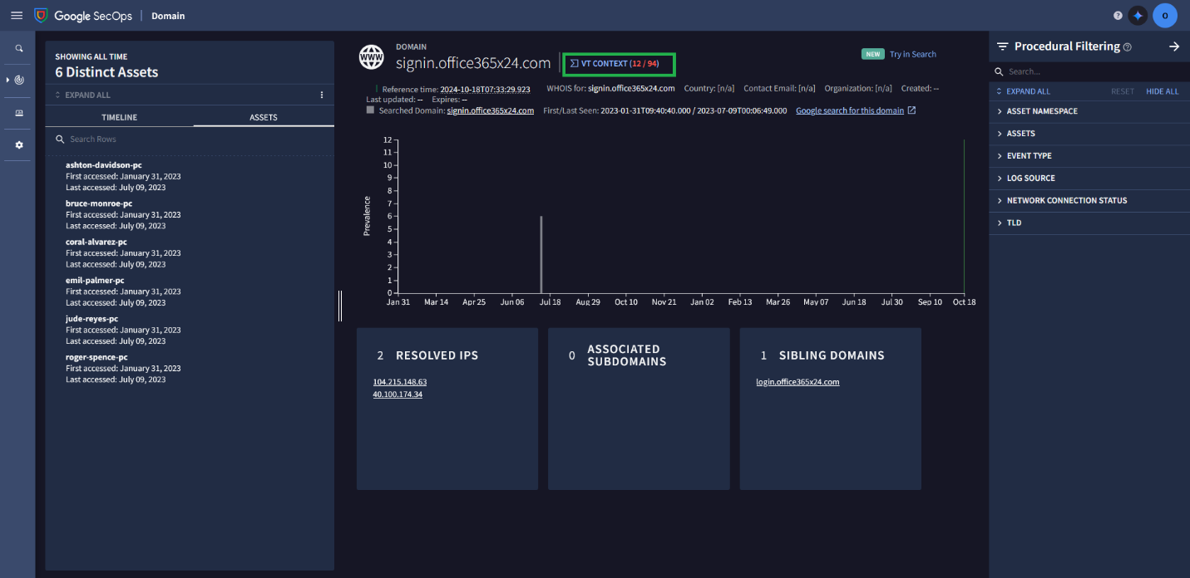

Doing so shows us that 12 vendors have flagged this particular domain as malicious.

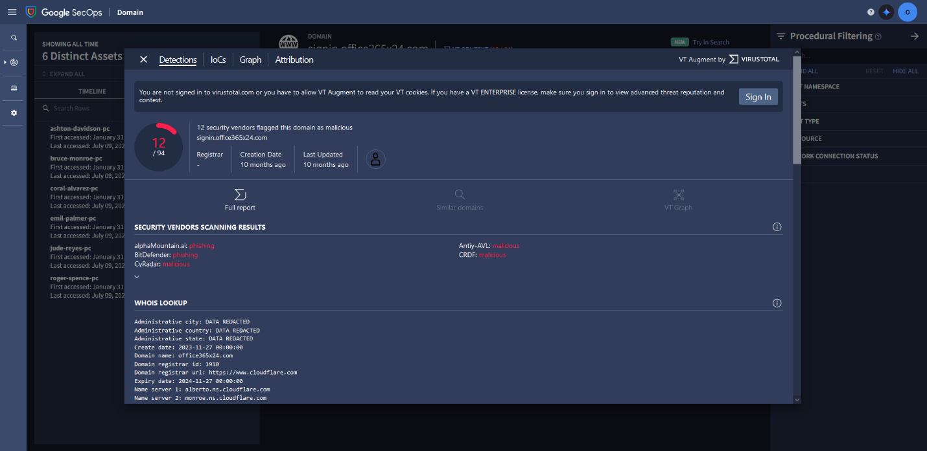

**Investigating Affected Assets and Events**

On the left side of the domain view page, we can see events and assets related to this domain on the **TIMELINE** and **ASSETS** tabs. **TIMELINE** shows the timeline of events that includes when each asset accessed the domain. **ASSETS** list hostnames, IP addresses, MAC addresses, or devices that have accessed the domain.

On the **ASSETS** tab we can see that 5 assets have have accessed this domain on the same day: **ashton-davidson-pc**, **bruce-monroe-pc**, **coral-alvarez-pc**, **emil-palmer-pc**, **jude-reyes-pc, and roger-spence-pc**.

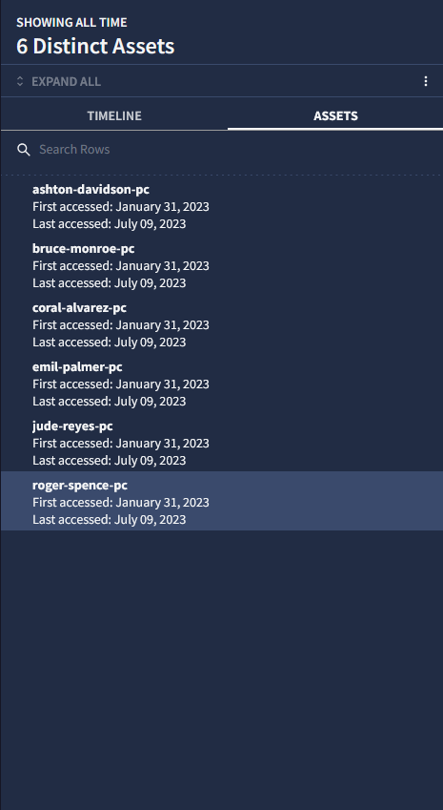

On the **TIMELINE** tab, clicking on **EXPAND ALL** reveals details about the HTTP requests made, including *GET* and *POST* requests. The more critical infromation here are the *POST* requests to the */login.php* page, because these may indicate a successful phishing attempt.

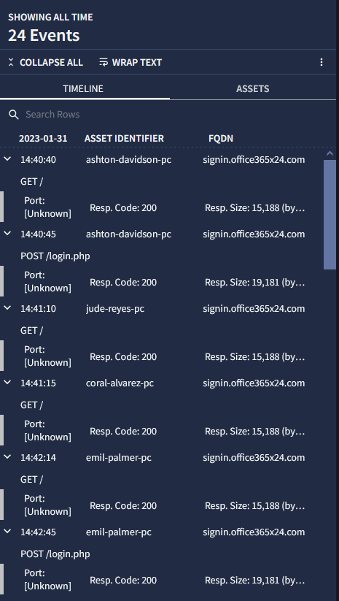

We identify 2 *POST* requests, one from **ashton-davidson-pc**, and one from **emil-palmer-pc** meaning that these two users’ credentails may have been compromized. Clicking on any of these post requests shows that the target URL of the web page that the *POST* requests were made to is http://signin.office365x24.com/login.php.

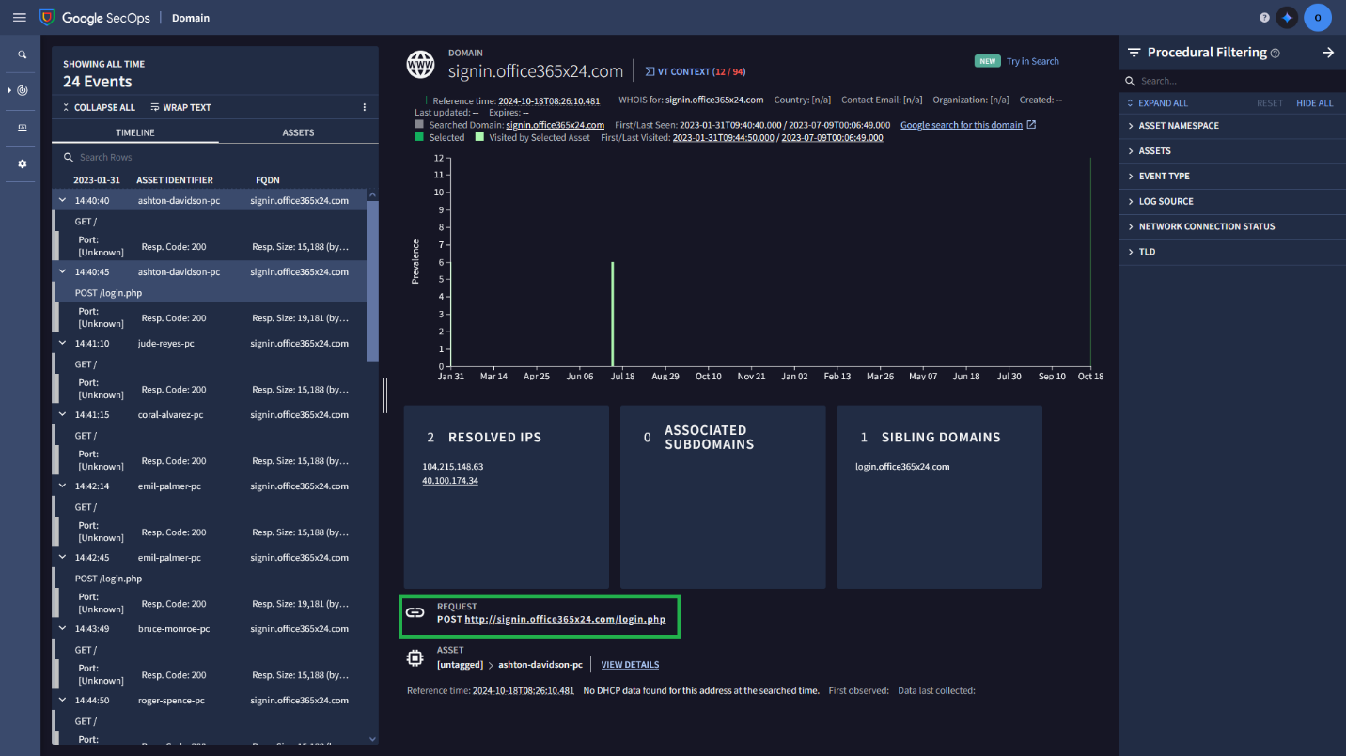

**Investigating the Resolved IP Address**

There is one more thing to do before concluding the investigation. Since attackers usually reuse the same infrastructure for multiple attacks, it is possible that multiple domain names resolve to the same IP address. We can go under the **RESOLVED IPS** insight card to identify if the *signin.office365x24.com* domain uses another domain.

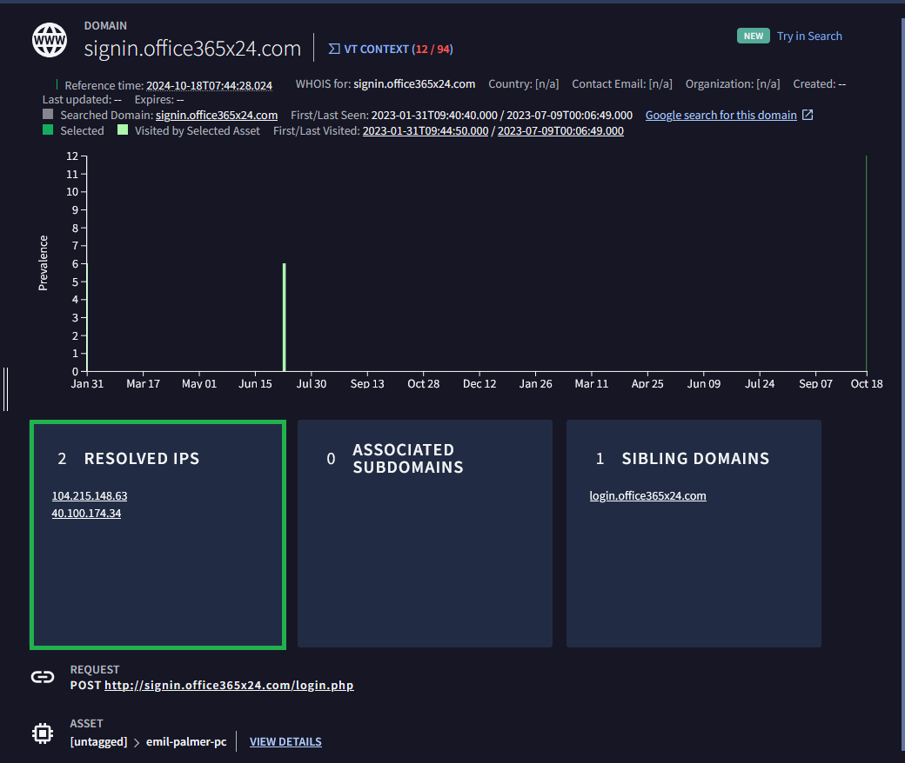

In this lab, querying for both *104.215.148.63* and *40.100.174.34* gives almost identical results, so in this case, let’s take a look at *40.100.174.34* and select the **DOMAINS** tab. We can see that *40.100.174.34* resolves to both *signin.accounts-gooqle.com* and *signin.office365x24.com*.

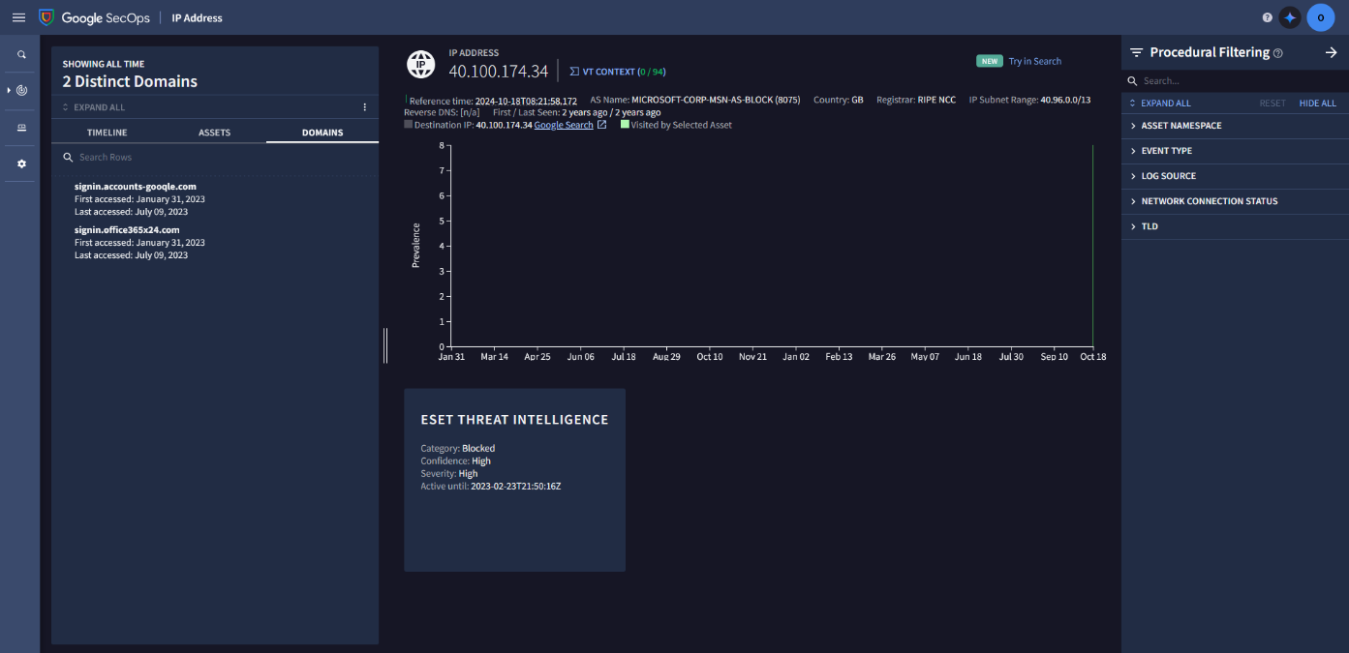

Let’s see if we can find any additonal infromation on the results page for this IP address that could help us with our investigation:

In the **ASSETS** tab we find that 2 additional assets have interacted with this malicious IP – **amir-david.pc** and **warren-morris-pc**. The **ESET THREAT INTELLIGENCE** insight card further confirms with high confidence that this IP address is indeed malicious and should be blocked.

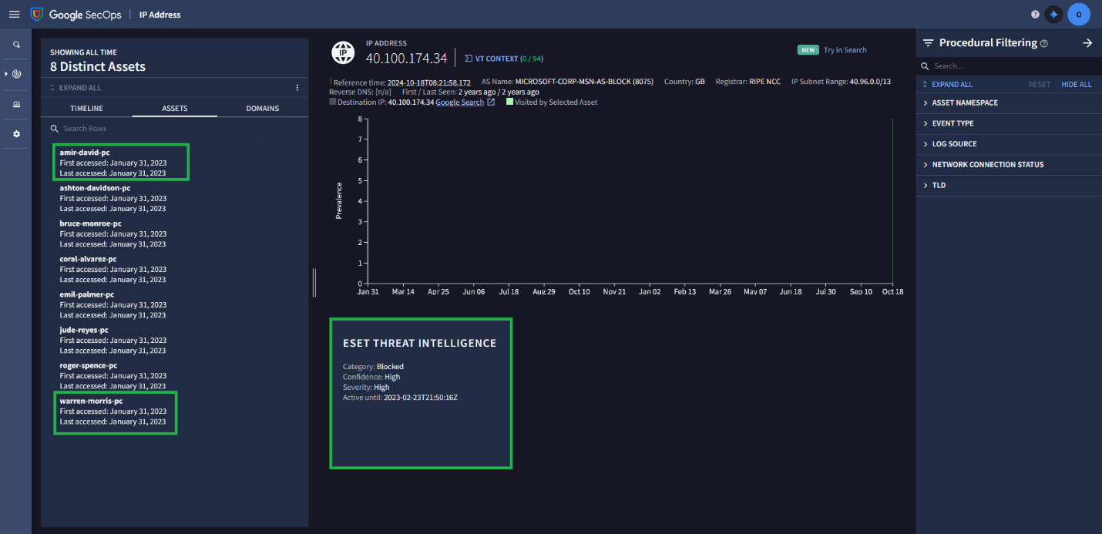

Clicking on **EXPAND ALL** on the **TIMELINE** tab reveals that an additioanal user’s credentials may have been compromised – **warren-morris-pc** has also made a *POST* request to this IP address.

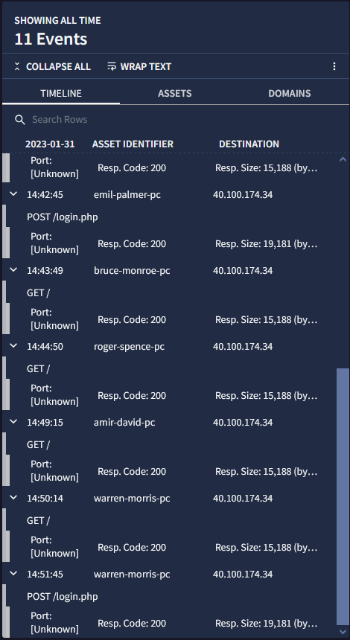

A more thorough investigation has thus allowed for a more accurate estimation of the scope of the phishing attack and its potential consequences.